COS70006 [Object-Oriented Programming (Semester 1)](https://swinburne.instructure.com/courses/40765)

Project 2

GUI components and its event handling functions

Lucas Qin

**Individual Assignment**

**Course Code**: COS70006

**Tutor**: Dr Wei Lai

**Student ID**: 103527269

**Student Name**: Lucas Qin

**Date**: 21/05/2022

# GUI components in project 2

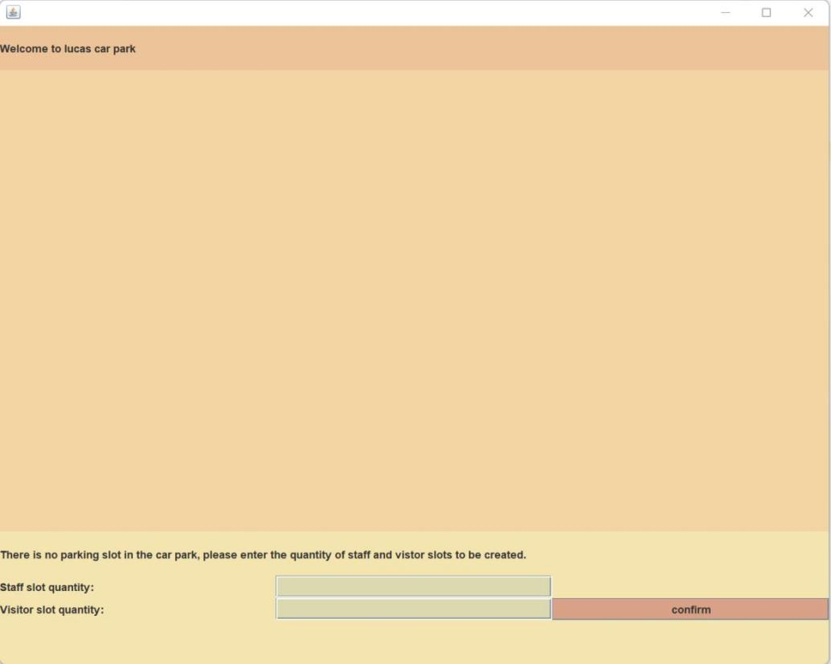

Fig.1 The first time user enter the system

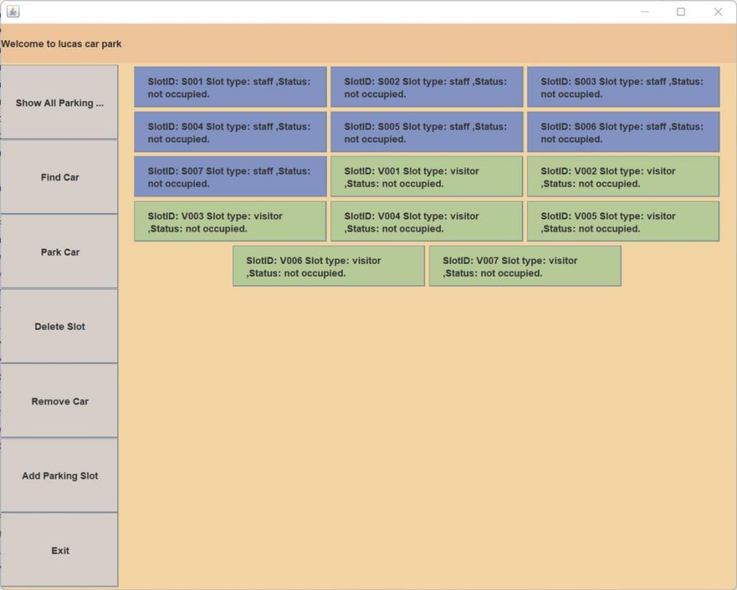

Fig.2 The main interface of the system

1. **JFrame** frame

Description: This a JFrame type component for making a frame that containing all other JComponents.  
2. **Container** contentPane

Description: This an JFrame’s method to provide a container for all JComponents.  
3. **JPanel** panel_btn

Description: This panel is for placing all left-side buttons.  
4. **JPanel** panel_welcome_info

Description: This panel is on the top and for placing welcome words to users.   
5. **JPanel** panel_content_top

Description: This panel is right under the panel_welcome_info and for displaying all parking slots.   
6. **JPanel** panel_content_bottom

Description: This panel is placed on the bottom of the interface, it only be visible the first time user open the system, it contains input column for user to provide the quantity of staff slot and visitor slots to be created initially.   
7. **JButton** showAll

Description: This button is on the left side and inside panel_btn, it attach to an event listener that enable user to display all parking slots when user click it.

1. **JButton** findCar

Description: This button is on the left side and inside panel_btn, it attach to an event listener that enable user to search for a car when user click it.   
9. **JButton** parkCar

Description: This button is on the left side and inside panel_btn, it attach to an event listener that enable user to park a car into a slot when user click it. User provide the car information and slot ID to park a car.  
10. **JButton** deleteSlot

Description: This button is on the left side and inside panel_btn, it attach to an event listener that enable user to delete a slot when user click it. User provide the slot ID to indicate which slot to be deleted.  
11. **JButton** removeCar

Description: This button is on the left side and inside panel_btn, it attach to an event listener that enable user to remove a car from a slot when user click it.   
12. **JButton** addParkingSlot

Description: This button is on the left side and inside panel_btn, it attach to an event listener that enable user to add a new parking slot when user click it.   
13. **JButton** exitApplication

Description: This button is on the left side and inside panel_btn, it attach to an event listener that enable user to exit the parking system when user click it.  
14. **JPanel** createSlot

Description: This panel is inside panel_content_bottom, it contains JComponent 16, 17, 18, 19, 20, 21 below, this part is for user to create staff and visitor slots the first time they using the parking system.   
15. **JLabel** welcomeLabel

This label is on the top inside panel_content_top for displaying a welcome sentence to user.

1. **JLabel** Staff

Description: This label is for displaying word “staff” to indicate the textfield’s purpose.  
17. **JLabel** Visitor

Description: This label is for displaying word “visitor” to indicate the textfield’s purpose.   
18. **JLabel** hints

Description: This label is for displaying instruction to tell user to enter the quantity of staff and visitor slot to be created the first time for using the system.   
19. **JButton** confirmCreate

Description: This button is a confirm button for created the amount of staff and visitor slot user entered. Once user pushed this button, the system will start creating slots and displaying the main interface of the system.  
20. **JTextField** staffSlots

Description: This text field is for user to provide the amount of staff slot to be created the first time using the system.   
21. **JTextField** visitorSlots

Description: This text field is for user to provide the amount of visitor slot to be created the first time using the system.

1. **JButton** Slots

This is the component that represent the parking slots on the system, it’s created dynamically based on need, if user created 2 slots, then there will be two of this button display on the panel_content_top, but with different name by using setName() method.

1. **GUI event handling functions**
2. **ActionListener ShowAllListener()**

Description: This action listener is triggered by clicking ‘showAll’ button, when it triggered, it will execute public ‘showAllSlot()’ method , which display all parking slots in panel_content_top.

1. **ActionListener FindCarListener()**

Description: This action listener is triggered by clicking ‘findCar’ button, when it triggered, it will execute findACar() method , which enable user to enter a car registration number and search for the car.

1. **ActionListener ParkCarListener()**

Description: This action listener is triggered by clicking ‘parkCar’ button, when it triggered, it will execute ‘parkACar()’ method , which allow user to enter their car registration number, owner name, user type and slot number to park a car into an existed slot.

1. **ActionListener DeleteSlotListener()**

Description: This action listener is triggered by clicking ‘deleteSlot’ button, when it triggered, it will execute ‘deleteCarSlot()’ method , which allow user to provide a slot id to delete a slot with no car parking.

1. **ActionListener RemoveCarListener()**

Description: This action listener is triggered by clicking ‘removeCar’ button, when it triggered, it will execute ‘removeACar()’ method , which allow user to remove a car from a slot by providing the car’s registration number.

1. **ActionListener AddParkingSlotListener1()**

Description: This action listener is triggered by clicking ‘confirmCreate’ button, when it triggered, it will execute ‘addCarSlot1()’ method , which enable users to enter staff and visitor slot quantity to be created.

1. **ActionListener AddParkingSlotListener2()**

Description: This action listener is triggered by clicking ‘addParkingSlot’ button, when it triggered, it will execute ‘addCarSlot2()’ method , which allow user to provide a slot ID to create a new parking slot.

1. **ActionListener ExitApplicationListener()**

Description: This action listener is triggered by clicking ‘exitApplication’ button, when it triggered, it will execute ‘windowClose()’ method , which allow user to exit the system and close the current window.

1. **ActionListener ClickedSlotListener()**

Description: This mouse listener is triggered by clicking ‘Slots’ button, when it triggered, it will provide 3 operation options for user to choose, they are ‘Park a car’, Remove a car’ and ‘Delete a slot’.

When user choose ‘Park a car’, the system will execute ‘clickParkcar(String slot_id)’ method, which allows user to park a car into a slot by clicking the slot, this method will catch the slot id of the slot clicked.

When user choose ‘Remove a car’, the system will execute ‘clickRemoveCar(String slot_id)’ method, which allow user to directly delete a car from a parking slot by clicking the slot, this method will detect the slot_id of the slot clicked.

When user choose ‘Delete a slot’, the system will execute ‘clickDeleteSlot(String slot_id)’ method, which allow user to directly delete a parking slot by clicking the slot, this method will detect the slot_id of the slot clicked.

1. **MouseListener ChangeColor()**

Description: This mouse listener is for changing to buttons on the left side to different color when being clicked and entered.